SIMATS ENGINEERING
ASSESSMENT TOOL 1

COURSE CODE: ITA 0606 COURSE NAME: MACHINE LEARNING

COURSE OUTCOME COVERED

CO2: Neural Network Representation, Perceptron Model, Multilayer Perceptrons, Backpropagation Algorithm, Deep Neural Networks, Genetic Algorithms, Hypothesis Space Search, Genetic Programming, Models of Evaluation and Learning (BL1, BL2)

Assessment Tool Weightage: 40%

QUESTIONS: 15 Total Marks:25

Annexure A

Analytical Problem Solving

Code of Conduct:

I k preetham chowdary/192321123 (Name / Reg No) certify that this submission is my original work and that I have adhered to the guidelines specified for this assessment.
I understand that any violation of academic integrity rules will result in disciplinary action.

Signature of the student:
K preetham chowdary

Annexure A

Short Answer Test

1, A simple perceptron model is used to classify whether a student passes or fails based on two input features, namely study hours and attendance. The weights associated with these inputs are 0.6 and 0.4 respectively, and the bias value is –0.5. For a given student with study hours equal to 2 and attendance equal to 1, compute the net input to the perceptron and apply the step activation function to determine the final output. Based on the result, conclude whether the student passes or fails.
(5 Marks)

Given:
- Study Hours (x₁) = 2
- Attendance (x₂) = 1
- Weight for Study Hours (w₁) = 0.6
- Weight for Attendance (w₂) = 0.4
- Bias (b) = –0.5

Formula:
Net Input = (w₁ × x₁) + (w₂ × x₂) + b Calculation:
Net Input = (0.6 × 2) + (0.4 × 1) + (–0.5)
= 1.2 + 0.4 – 0.5
= 1.1

Step Activation Function: • If Net Input ≥ 0, Output = 1
- If Net Input < 0, Output = 0
Since the Net Input is 1.1, which is greater than 0,

Output = 1

Conclusion:
The perceptron output is 1, which indicates that the student Passes.

Final Result:
- Net Input = 1.1
- Perceptron Output = 1
- Student Status = Pass

Python Program
# Perceptron Model for Student Pass/Fail Classification

# Input values study_hours = 2
attendance = 1

# Weights w1 = 0.6 w2 = 0.4

# Bias bias = -0.5

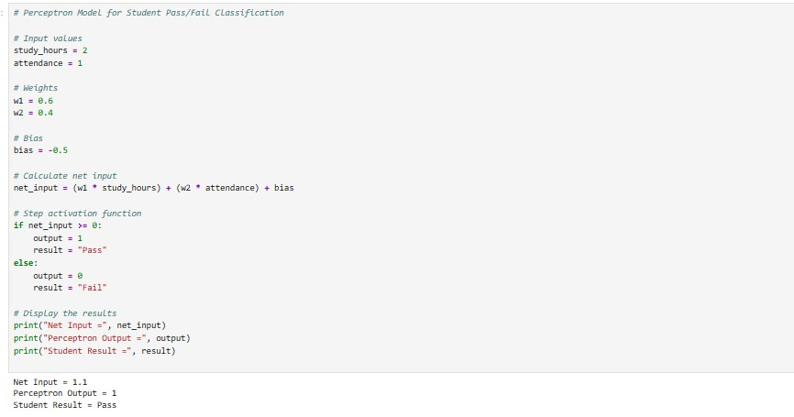
# Calculate net input
net_input = (w1 * study_hours) + (w2 * attendance) + bias

# Step activation function if net_input >= 0: output = 1 result = "Pass" else:
output = 0
result = "Fail"

# Display the results print("Net Input =", net_input) print("Perceptron Output =", output) print("Student Result =", result)
Output:
2. In a neural network, a single neuron is trained using the backpropagation learning rule. The initial weight is 0.5 and the learning rate is 0.1. For an input value of 2, the actual output produced by the neuron is 0.6, whereas the target output is 1. Calculate the error in the output and determine the weight update using the delta rule. Hence, compute the new updated weight after one iteration of training. (5 Marks)

Given:
- Initial Weight (w) = 0.5
- Learning Rate (η) = 0.1
- Input (x) = 2
- Actual Output (y) = 0.6
- Target Output (t) = 1

Formula 1: Calculate the Error
Error = Target Output − Actual Output

Calculation:
Error = 1 − 0.6
= 0.4

Formula 2: Delta Rule (Weight Update)
Δw = η × Error × Input Where:
- η = Learning Rate
- Error = Target Output − Actual Output
- Input = x

Calculation:
Δw = 0.1 × 0.4 × 2
= 0.08

Formula 3: Updated Weight
New Weight = Old Weight + Δw

Calculation:
New Weight = 0.5 + 0.08
= 0.58

Conclusion:
After one iteration of backpropagation learning:
- Error = 0.4
- Weight Update (Δw) = 0.08
- Updated Weight = 0.58
Hence, the new weight after one training iteration is 0.58.

Python Program
# Backpropagation Weight Update using Delta Rule

# Given values weight = 0.5
learning_rate = 0.1
input_value = 2
target_output = 1
actual_output = 0.6

# Calculate error
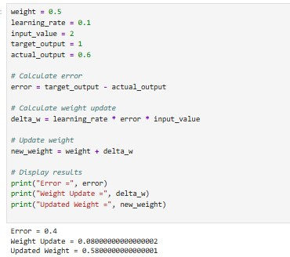
error = target_output - actual_output

# Calculate weight update
delta_w = learning_rate * error * input_value

# Update weight new_weight = weight + delta_w

# Display results print("Error =", error) print("Weight Update =", delta_w)
print("Updated Weight =", new_weight)

Output:

3. A deep learning model is developed for disease prediction and its performance is evaluated using a confusion matrix. The model yields 180 true positives, 150 true negatives, 20 false positives, and 50 false negatives. Using these values, compute the accuracy, precision, sensitivity (recall), and specificity of the model. Based on the calculated results, discuss whether the model is reliable for medical diagnosis, considering the importance of minimizing diagnostic errors. (5 Marks)

Given:
- True Positives (TP) = 180
- True Negatives (TN) = 150
- False Positives (FP) = 20
- False Negatives (FN) = 50

Formula 1: Accuracy
Accuracy = (TP + TN) / (TP + TN + FP + FN)

Calculation:
Accuracy = (180 + 150) / (180 + 150 + 20 + 50)
= 330 / 400
= 0.825
Accuracy = 82.5%

Formula 2: Precision
Precision = TP / (TP + FP)

Calculation:
Precision = 180 / (180 + 20)
= 180 / 200
= 0.90
Precision = 90%

Formula 3: Sensitivity (Recall)
Sensitivity (Recall) = TP / (TP + FN)

Calculation:
Sensitivity = 180 / (180 + 50)
= 180 / 230
= 0.7826
Sensitivity = 78.26%

Formula 4: Specificity
Specificity = TN / (TN + FP)

Calculation:
Specificity = 150 / (150 + 20)
= 150 / 170
= 0.8824
Specificity = 88.24%

# Performance Evaluation using Confusion Matrix

TP = 180
TN = 150
FP = 20
FN = 50

# Calculations
accuracy = (TP + TN) / (TP + TN + FP + FN) precision = TP / (TP + FP) sensitivity = TP / (TP + FN)
specificity = TN / (TN + FP)

# Display Results print("Accuracy =", round(accuracy * 100, 2), "%") print("Precision =", round(precision * 100, 2), "%") print("Sensitivity (Recall) =", round(sensitivity * 100, 2), "%")
print("Specificity =", round(specificity * 100, 2), "%")

Output:

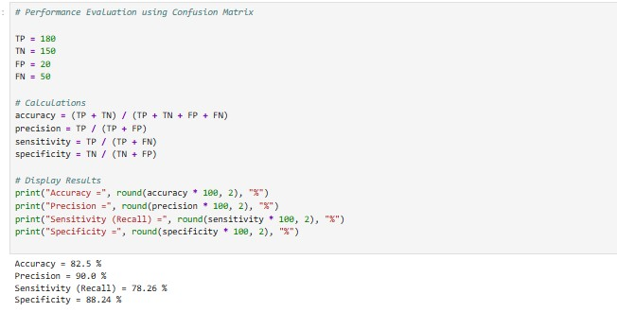

4.A Genetic Algorithm is applied to maximize the function f(x) = x² using an initial population consisting of the values 2, 4, 6, and 8. Determine the fitness value for each individual in the population and select the best candidates based on their fitness scores. Perform a crossover operation by exchanging the least significant bits of the selected individuals to generate new offspring. Additionally, explain the role of mutation in improving the diversity and effectiveness of the solution in Genetic Algorithms.
(5 Marks)

Given:
- Objective Function: f(x) = x²
- Initial Population: 2, 4, 6, 8

Step 1: Calculate the Fitness Value The fitness function is:
Fitness = f(x) = x²
Individual (x) | Fitness = x²
2 | 4
4 | 16
6 | 36
8 | 64

Step 2: Selection
Individuals with the highest fitness values are selected for reproduction.
Selected Individuals:
- 8 (Fitness = 64)
- 6 (Fitness = 36)
These individuals are chosen because they have the highest fitness scores.

Step 3: Crossover
Binary Representation
- 8 = 1000
- 6 = 0110
Exchange the Least Significant Bit (LSB) of both parents.
Parent 1: 1000
Parent 2: 0110
After exchanging the last bit:
Offspring 1: 1000 = 8
Offspring 2: 0110 = 6
Since both LSBs are 0, the offspring remain unchanged.
New Offspring:
- Offspring 1 = 8
- Offspring 2 = 6

# Genetic Algorithm Example # Initial population population = [2, 4, 6, 8] # Calculate fitness fitness = [x**2 for x in population] print("Population:", population)
print("Fitness Values:", fitness)

# Select best two individuals
selected = sorted(population, key=lambda x: x**2, reverse=True)[:2] print("Selected Individuals:", selected)

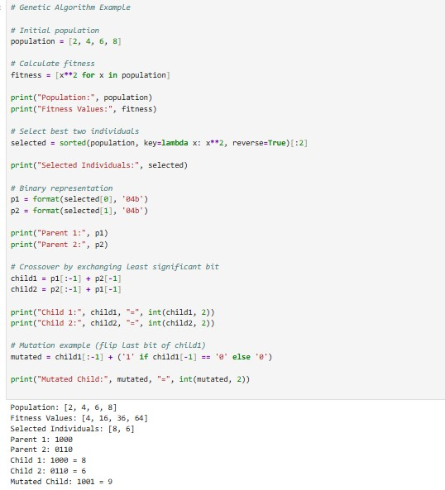
# Binary representation p1 = format(selected[0], '04b') p2 = format(selected[1], '04b') print("Parent 1:", p1) print("Parent 2:", p2)

# Crossover by exchanging least significant bit
child1 = p1[:-1] + p2[-1] child2 = p2[:-1] + p1[-1] print("Child 1:", child1, "=", int(child1, 2)) print("Child 2:", child2, "=", int(child2, 2))

# Mutation example (flip last bit of child1) mutated = child1[:-1] + ('1' if child1[-1] == '0' else '0')
print("Mutated Child:", mutated, "=", int(mutated, 2))

Output
5 .During the training of a deep neural network model, the training and validation accuracies are observed over multiple epochs. The training accuracy increases steadily from 60% to 95%, while the validation accuracy initially increases from 58% to 72% but then decreases to 68% in later epochs. Analyse this trend and identify the issue affecting the model after a certain point in training. Explain why this issue occurs in neural networks and suggest two effective techniques to address it. Also, discuss the significance of validation accuracy in evaluating the performance of a learning
model. (5 Marks)

Given:
- Training Accuracy: Increases from 60% to 95%
- Validation Accuracy: Increases from 58% to 72%, then decreases to 68%

Analysis
Initially, both the training and validation accuracies improve, which indicates that the model is learning useful patterns from the training data.
However, after a certain number of epochs:
- The training accuracy continues to increase from 72% to 95%.
- The validation accuracy decreases from 72% to 68%. This indicates that the model is suffering from Overfitting.

Techniques to Reduce Overfitting

- Dropout
  - Dropout randomly deactivates some neurons during training.
  - It prevents the network from depending too much on specific neurons.
  - This improves the model's ability to generalize.

- Early Stopping
  - Early stopping monitors the validation accuracy during training.
  - Training is stopped when the validation accuracy stops improving or starts decreasing.
  - This prevents the model from overfitting the training data.

Conclusion
The decrease in validation accuracy while training accuracy continues to improve indicates overfitting. This happens because the model memorizes the training data instead of learning general patterns. Using Dropout and Early Stopping can effectively reduce overfitting. Validation accuracy is an important metric because it reflects the model's performance on unseen data and helps build a reliable deep learning model.

# Training and Validation Accuracy Analysis

training_accuracy = [60, 70, 80, 90, 95]
validation_accuracy = [58, 65, 72, 70, 68]

print("Epoch\tTraining\tValidation")

for i in range(len(training_accuracy)): print(f"{i+1}\t{training_accuracy[i]}%\t\t{validation_accuracy[i]}%")

# Detect overfitting if training_accuracy[-1] > training_accuracy[-2] and validation_accuracy[-1] < validation_accuracy[-2]: print("\nThe model is suffering from Overfitting.") else:
print("\nThe model is performing normally.")

Output
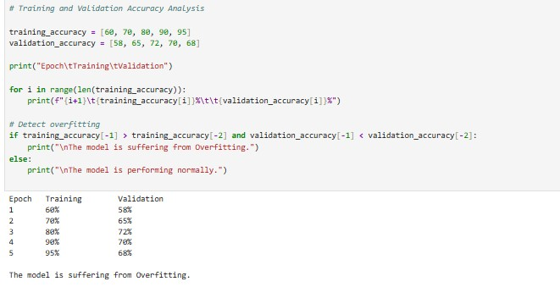

RUBRICS FOR CALCULATION

Criteria | Weightage | Level 4 –  Exemplary (5 Marks) | Level 3 –  Proficient (4 Marks) | Level 2 –  Developing (2–3 Marks) | Level 1 –  Beginning (0–1  Mark)
Conceptual  Understanding | 25 | Demonstrates clear and complete understanding of the concept | Good  understanding  with minor gaps | Basic understanding with some  misconceptions | Poor or incorrect  understanding
Accuracy of  Answer | 25 | Completely correct answer with no  errors | Mostly correct  with minor errors | Partially correct  with noticeable  errors | Incorrect or  irrelevant answer
Application of Knowledge | 20 | Correctly applies concepts to solve  the  question/problem | Applies concepts  with minor  mistakes | Limited or partially  correct application | No or incorrect application
Completeness of Response | 15 | Covers all required parts of the  question | Covers most parts with minor  omissions | Covers only some  parts | Incomplete or missing response
Clarity &  Presentation | 15 | Clear, concise, and well-organized answer | Understandable with minor issues | Somewhat unclear or poorly structured | Difficult to understand

